Visual Studio Code Task 1 – Earth to Moon Weights

By Dario Gerald

My design:

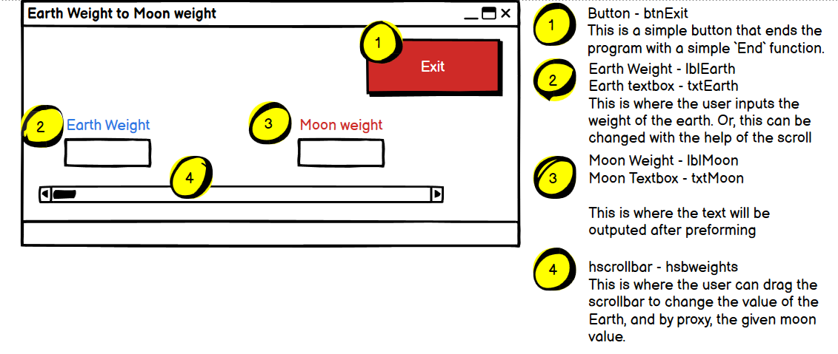

**Psuedocode**

BtnExit

Start

End program

Stop

Txtweighhts

Start

Earthweight = hscrollbar value  
 Moon weight = Earth Weight * 0.165  
 Display Moon weight

End

**Testing Table**

|  |  |  |  |
| --- | --- | --- | --- |
| **DATA** | **EXPECTED RESULT** | **ACTUAL RESULT** | **FIX** |
| Earth = 200 | Moon = 33 | 33.0kg | N/A |
| Earth = 0 | Moon = 0 | 0.0kg | N/A |
| Earth = 1 | Moon = 0.2 | 0.2kg | N/A |
| Earth = 199 | Moon = 32.8 | 32.8kg | N/A |
| Earth = 122 | Moon = 20.1 | 20.1kg | N/A |
| Earth = 100 | Moon = 16.5 | 16.5kg | N/A |